**Recommendations**

**Conservative Increase:** Considering the substantial increase last year, a more conservative increase might be prudent to avoid hitting a price ceiling where demand starts to decrease. An increase of 10%-15% might be useful to test the markets response without risking loss of customers.

**Price Setting**

* The price in 2022 was £4.99, a 10% increase would make the new price approximately £5.49.
* A 15% increase would set the price at approximately £5.74.

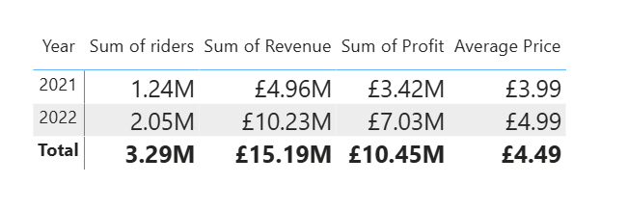**Recommendation Strategy:**

**Market Analysis:** Conduct further market research to understand customer satisfaction, competitive changes and economic environment. This can guide the Price setting adjustment to a lower or higher end of the increase.

**Segmented Pricing Strategy:** Consider different pricing for registered users vs casual users as the customer categories may have different price sensitivities.

**Monitor and Adjust:** Implement new prices but carefully monitor customer sales data and feedback and adjust accordingly. Tracking data closely will allow fine tuning of pricing strategy without committing to a price which might turn out to be too high.